// Buscar el reporte del crimen

select *

from crime_scene_report

where date="20180115" and type="murder" and city="SQL City";

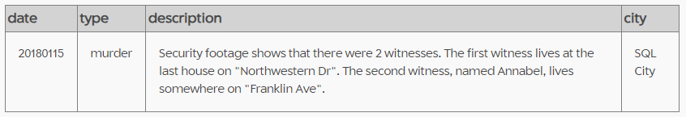

# 🡪 Annabel Miller {Franklin Ave}

select *

from person

where name like "%Annabel%" and address_street_name like "%Franklin Ave%";

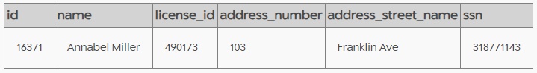

# 🡪 Morty Schapiro {Northwestern Dr}

select *

from person

where address_street_name like "%Northwestern Dr%" and address_number =

(select max(address_number) from person);

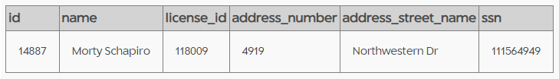

# 🡪 Interrogatorios

// Los dos primeros testigos

select p.name, i.transcript

from person p

inner join interview i

on p.id=i.person_id

where p.id in ("16371","14887"); 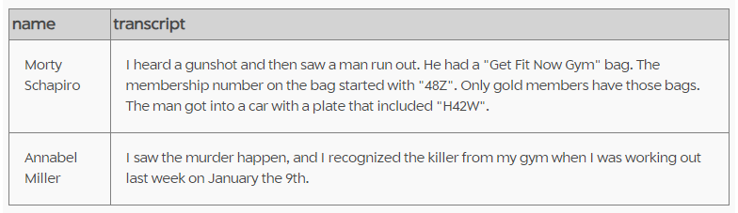

# 🡪 Sospechoso: Jeremy Bowers

select *

from get_fit_now_member fm0 left join person p0

on fm0.person_id = p0.id

where fm0.id like "48Z%" and exists

(select p0.license_id

from drivers_license d1

where p0.license_id=d1.id and d1.plate_number like "%H42W%");

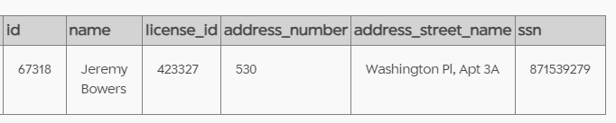

// GYM

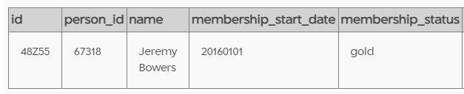

// Last week January the 9th

select *

from get_fit_now_check_in

where membership_id="48Z55";

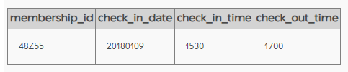

//Interrogatorio

select p.name, i.transcript

from person p

inner join interview i

on p.id=i.person_id

where p.id in ("67318");

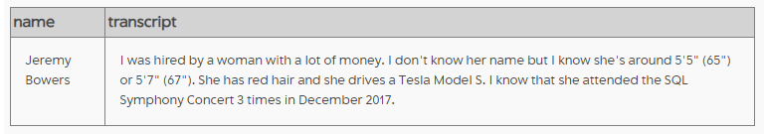

select *

from person p0

where exists

(select p0.id )